**Exercise 1: Student Information System using Array Implementation of list ADT**

**studADT.h:**

#include<stdio.h>

struct stud

{

int rno;

char name[30];

int m1,m2,m3;

int total;

char result;

};

struct studADT

{

struct stud s[15];

int max;

};

void init(struct studADT *S,int n);

void insert(struct studADT *S);

void display(struct studADT S);

void insDet(struct stud *s);

void insertFront(struct studADT *S,struct stud *s);

void insertEnd(struct studADT *S,struct stud *a);

void insertRegNo(struct studADT *S,struct stud *a, int regNum);

struct studADT searchName(struct studADT,char name[]);

void del(struct studADT *S,int regNum);

void computeResult(struct studADT *S);

struct studADT listResult(struct studADT S);

int listClass(struct studADT S);

**studimpl.h:**

#include "studADT.h"

#include<string.h>

void init(struct studADT *S,int n)

{

S->max=n;

}

void insert(struct studADT *S)

{

//for i<S->max

//int i=0;

printf("\nEnter Student details: \n");

for(int i=0;i<S->max;i++)

{

printf("\nEnter Roll No: ");

scanf("%d",&S->s[i].rno);

printf("Enter Name:");

scanf("%s",S->s[i].name);

printf("Enter mark 1,2 and 3: ");

scanf("%d%d%d",&(S->s[i].m1),&S->s[i].m2,&S->s[i].m3);

}

}

void display(struct studADT S)

{

printf("\nRecords: \n");

for(int i=0;i<S.max;i++)

{

printf("\nName: %s",S.s[i].name);

printf("\nRno: %d",S.s[i].rno);

printf("\nMark 1: %d\nMark 2: %d\nMark 3: %d",S.s[i].m1,S.s[i].m2,S.s[i].m3);

printf("\nTotal : %d",S.s[i].total);

printf("\nResult: %c\n",S.s[i].result);

}

}

void insDet(struct stud *s)

{

printf("\nNew Student Details: \n");

printf("Enter Roll No: ");

scanf("%d",&s->rno);

printf("Enter Name:");

scanf("%s",s->name);

printf("Enter mark 1,2 and 3: ");

scanf("%d%d%d",&s->m1,&s->m2,&s->m3);

}

void insertFront(struct studADT *S,struct stud *a)

{

for(int i=S->max;i>=0;i--)

{

S->s[i+1]=S->s[i];

}

S->s[0]=*a;

S->max++;

}

void insertEnd(struct studADT *S,struct stud *a)

{

S->s[S->max]=*a;

S->max++;

}

void insertRegNo(struct studADT *S,struct stud *a, int regNum)

{

int i;

for(i=0;i<S->max;i++)

{

if(S->s[i].rno==regNum)

{

//struct stud *temp=NULL;

S->max++;

for(int j=S->max;j>i+1;j--)

{

S->s[j]=S->s[j-1];

}

S->s[i+1]=*a;

break;

}

}

//S->max++;

}

struct studADT searchName(struct studADT S,char name[])

{

struct studADT ptr;

int count=0;

ptr.max=1;

strcpy(ptr.s[0].name,"N/A");

ptr.s[0].rno=0;

ptr.s[0].m1=ptr.s[0].m2=ptr.s[0].m3=ptr.s[0].total=0,ptr.s[0].result='X';

for(int i=0;i<S.max;i++)

{

if(strcmp(S.s[i].name,name)==0)

{

ptr.s[ptr.max-1]=S.s[i];

ptr.max++;

count=1;

}

}

ptr.max-=count?1:0;

return ptr;

}

void del(struct studADT *S,int regNum)

{

for(int i=0;i<S->max;i++)

{

if(S->s[i].rno==regNum)

{

for(int j=i;j<S->max-1;j++)

{

S->s[j]=S->s[j+1];

}

S->max--;

break;

}

}

}

void computeResult(struct studADT *S)

{

for(int i=0;i<S->max;i++)

{

S->s[i].total=S->s[i].m1+S->s[i].m2+S->s[i].m3;

S->s[i].result=S->s[i].m1>50 && S->s[i].m2>50 && S->s[i].m3>50?'P':'F';

}

}

struct studADT listResult(struct studADT S)

{

struct studADT s;

s.max=0;

//rintf("\nmax: %d\n",S.max);

for(int i=0;i<S.max;i++)

{

if(S.s[i].result=='P')

{

insertEnd(&s,&S.s[i]);

}

}

return s;

}

int listClass(struct studADT S)

{

int count=0;

for(int i=0;i<S.max;i++)

{

if(S.s[i].total>90)

count++;

}

return count;

}

**studappl.c:**

#include<stdio.h>

#include "studimpl.h"

int main()

{

struct studADT s;

struct stud S;

int ch,n;

printf("No of Records to be Inserted: ");

scanf("%d",&n);

init(&s,n);

insert(&s);

computeResult(&s);

display(s);

do{

printf("\n-----------------------------------------------\nMenu: \n\n1.Insert a record at Front\n2.Insert a Record at Back\n3.After a RegNo\n4.Search Name\n5.Delete a Record\n6.List details of Students those who passed\n7.List the number of Students who secured FirstClass\n8.Exit\n\nEnter your choice: ");

scanf("%d",&ch);

switch(ch)

{

case 1: printf("\nAt Front: \n");

insDet(&S);

insertFront(&s,&S);

computeResult(&s);

display(s);

break;

case 2: printf("\nAt End: \n");

insDet(&S);

//computeResult(&s);

insertEnd(&s,&S);

computeResult(&s);

display(s);

break;

case 3: printf("\nAfter RegNo: \n");

printf("\nInsert After Reg. No.: ");

int rno,i;

scanf("%d",&rno);

for(i=0;i<s.max;i++)

{

if(s.s[i].rno==rno)

break;

}

if(i==s.max)

printf("\n%d is not in the records, new record is not inserted!\n",rno);

else

{

insDet(&S);

//computeResult(&s);

insertRegNo(&s,&S,rno);

computeResult(&s);

display(s);

}

break;

case 4: printf("\nSearch Name: \n");

printf("\nEnter Name: ");

char key[30];

scanf("%s",key);

struct studADT p;

//printf("\nmax: %d\n",p.max);

p=searchName(s,key);

display(p);

break;

case 5: printf("\nDeletion: \n");

printf("\nEnter Reg. No.: ");

scanf("%d",&rno);

del(&s,rno);

display(s);

break;

case 6: printf("\nPassed students:\n");

struct studADT FC;

FC=listResult(s);

//printf("\nmax: %d\n",FC.max);

if(FC.max!=0)

display(FC);

else

printf("\nNo one passed!\n");

break;

case 7: printf("\nNumber of FC Students: %d\n",listClass(s));

break;

case 8: return 0;

break;

default: printf("\nInvalid Input!\n");

}

}while(ch!=8);

return 0;

}

**Sample I/O:**

**(new one):**

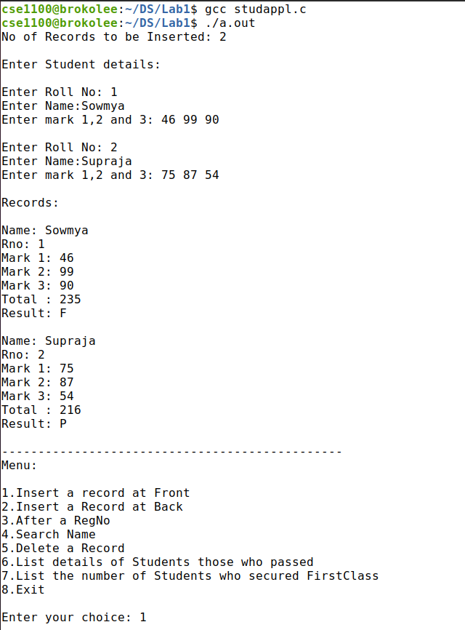

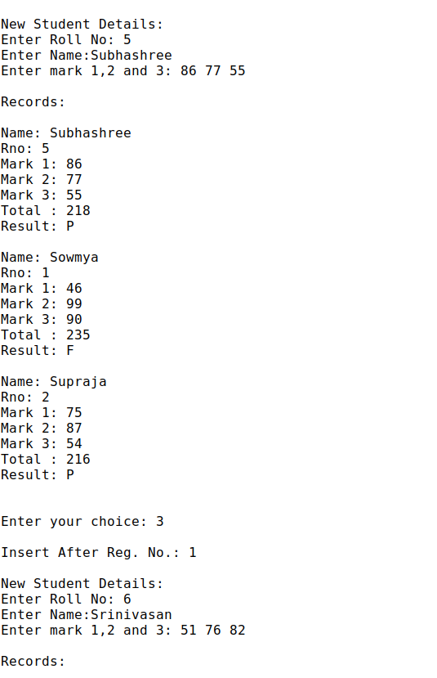

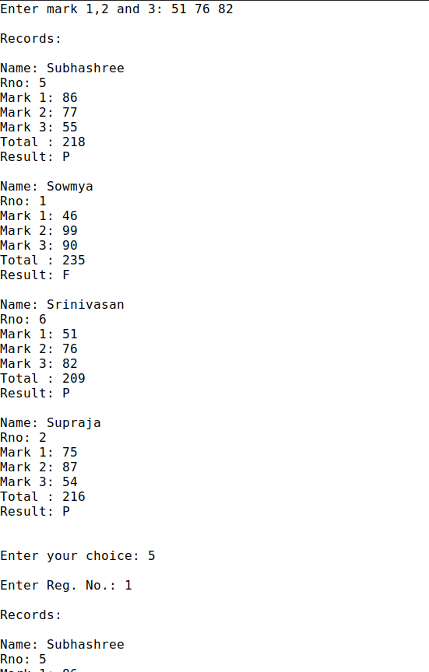

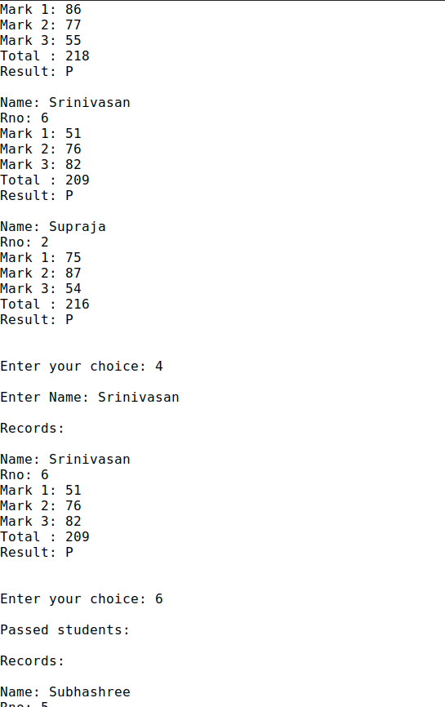

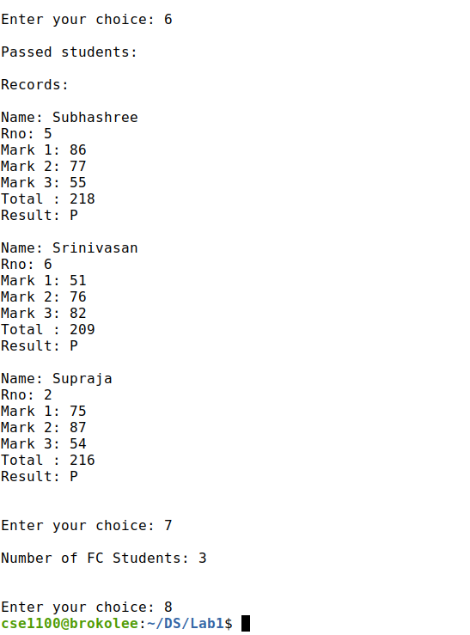

**Old one:**

No of Records to be Inserted: 2

Enter Student details:

Enter Roll No: 420

Enter Name:Harini

Enter mark 1,2 and 3: 69 99 90

Enter Roll No: 1

Enter Name:Shiv

Enter mark 1,2 and 3: 91 92 93

Records:

Name: Harini

Rno: 420

Mark 1: 69

Mark 2: 99

Mark 3: 90

Total : 258

Result: P

Name: Shiv

Rno: 1

Mark 1: 91

Mark 2: 92

Mark 3: 93

Total : 276

Result: P

-----------------------------------------------

Menu:

1.Insert a record at Front

2.Insert a Record at Back

3.After a RegNo

4.Search Name

5.Delete a Record

6.List details of Students those who passed

7.List the number of Students who secured FirstClass

8.Exit

Enter your choice: 1

At Front:

New Student Details:

Enter Roll No: 10

Enter Name:Abhinav

Enter mark 1,2 and 3: 40 50 30

Records:

Name: Abhinav

Rno: 10

Mark 1: 40

Mark 2: 50

Mark 3: 30

Total : 120

Result: F

Name: Harini

Rno: 420

Mark 1: 69

Mark 2: 99

Mark 3: 90

Total : 258

Result: P

Name: Shiv

Rno: 1

Mark 1: 91

Mark 2: 92

Mark 3: 93

Total : 276

Result: P

-----------------------------------------------

Menu:

1.Insert a record at Front

2.Insert a Record at Back

3.After a RegNo

4.Search Name

5.Delete a Record

6.List details of Students those who passed

7.List the number of Students who secured FirstClass

8.Exit

Enter your choice: 2

At End:

New Student Details:

Enter Roll No: 100

Enter Name:Muthu

Enter mark 1,2 and 3: 70 90 85

Records:

Name: Abhinav

Rno: 10

Mark 1: 40

Mark 2: 50

Mark 3: 30

Total : 120

Result: F

Name: Harini

Rno: 420

Mark 1: 69

Mark 2: 99

Mark 3: 90

Total : 258

Result: P

Name: Shiv

Rno: 1

Mark 1: 91

Mark 2: 92

Mark 3: 93

Total : 276

Result: P

Name: Muthu

Rno: 100

Mark 1: 70

Mark 2: 90

Mark 3: 85

Total : 245

Result: P

-----------------------------------------------

Menu:

1.Insert a record at Front

2.Insert a Record at Back

3.After a RegNo

4.Search Name

5.Delete a Record

6.List details of Students those who passed

7.List the number of Students who secured FirstClass

8.Exit

Enter your choice: 3

After RegNo:

Insert After Reg. No.: 1

New Student Details:

Enter Roll No: 89

Enter Name:Tharuniyaa

Enter mark 1,2 and 3: 75 74 73

Records:

Name: Tharuniyaa

Rno: 89

Mark 1: 75

Mark 2: 74

Mark 3: 73

Total : 222

Result: P

Name: Abhinav

Rno: 10

Mark 1: 40

Mark 2: 50

Mark 3: 30

Total : 120

Result: F

Name: Harini

Rno: 420

Mark 1: 69

Mark 2: 99

Mark 3: 90

Total : 258

Result: P

Name: Shiv

Rno: 1

Mark 1: 91

Mark 2: 92

Mark 3: 93

Total : 276

Result: P

Name: Muthu

Rno: 100

Mark 1: 70

Mark 2: 90

Mark 3: 85

Total : 245

Result: P

-----------------------------------------------

Menu:

1.Insert a record at Front

2.Insert a Record at Back

3.After a RegNo

4.Search Name

5.Delete a Record

6.List details of Students those who passed

7.List the number of Students who secured FirstClass

8.Exit

Enter your choice: 1

At Front:

New Student Details:

Enter Roll No: 3

Enter Name:Shiv

Enter mark 1,2 and 3: 10 20 30

Records:

Name: Shiv

Rno: 3

Mark 1: 10

Mark 2: 20

Mark 3: 30

Total : 60

Result: F

Name: Tharuniyaa

Rno: 89

Mark 1: 75

Mark 2: 74

Mark 3: 73

Total : 222

Result: P

Name: Abhinav

Rno: 10

Mark 1: 40

Mark 2: 50

Mark 3: 30

Total : 120

Result: F

Name: Harini

Rno: 420

Mark 1: 69

Mark 2: 99

Mark 3: 90

Total : 258

Result: P

Name: Shiv

Rno: 1

Mark 1: 91

Mark 2: 92

Mark 3: 93

Total : 276

Result: P

Name: Muthu

Rno: 100

Mark 1: 70

Mark 2: 90

Mark 3: 85

Total : 245

Result: P

-----------------------------------------------

Menu:

1.Insert a record at Front

2.Insert a Record at Back

3.After a RegNo

4.Search Name

5.Delete a Record

6.List details of Students those who passed

7.List the number of Students who secured FirstClass

8.Exit

Enter your choice: 4

Search Name:

Enter Name: Shiv

Records:

Name: Shiv

Rno: 3

Mark 1: 10

Mark 2: 20

Mark 3: 30

Total : 60

Result: F

Name: Shiv

Rno: 1

Mark 1: 91

Mark 2: 92

Mark 3: 93

Total : 276

Result: P

-----------------------------------------------

Menu:

1.Insert a record at Front

2.Insert a Record at Back

3.After a RegNo

4.Search Name

5.Delete a Record

6.List details of Students those who passed

7.List the number of Students who secured FirstClass

8.Exit

Enter your choice: 4

Search Name:

Enter Name: Blahblah

Records:

Name: N/A

Rno: 0

Mark 1: 0

Mark 2: 0

Mark 3: 0

Total : 0

Result: X

-----------------------------------------------

Menu:

1.Insert a record at Front

2.Insert a Record at Back

3.After a RegNo

4.Search Name

5.Delete a Record

6.List details of Students those who passed

7.List the number of Students who secured FirstClass

8.Exit

Enter your choice: 5

Deletion:

Enter Reg. No.: 100

Records:

Name: Shiv

Rno: 3

Mark 1: 10

Mark 2: 20

Mark 3: 30

Total : 60

Result: F

Name: Tharuniyaa

Rno: 89

Mark 1: 75

Mark 2: 74

Mark 3: 73

Total : 222

Result: P

Name: Abhinav

Rno: 10

Mark 1: 40

Mark 2: 50

Mark 3: 30

Total : 120

Result: F

Name: Harini

Rno: 420

Mark 1: 69

Mark 2: 99

Mark 3: 90

Total : 258

Result: P

Name: Shiv

Rno: 1

Mark 1: 91

Mark 2: 92

Mark 3: 93

Total : 276

Result: P

-----------------------------------------------

Menu:

1.Insert a record at Front

2.Insert a Record at Back

3.After a RegNo

4.Search Name

5.Delete a Record

6.List details of Students those who passed

7.List the number of Students who secured FirstClass

8.Exit

Enter your choice: 6

Passed students:

Records:

Name: Tharuniyaa

Rno: 89

Mark 1: 75

Mark 2: 74

Mark 3: 73

Total : 222

Result: P

Name: Harini

Rno: 420

Mark 1: 69

Mark 2: 99

Mark 3: 90

Total : 258

Result: P

Name: Shiv

Rno: 1

Mark 1: 91

Mark 2: 92

Mark 3: 93

Total : 276

Result: P

-----------------------------------------------

Menu:

1.Insert a record at Front

2.Insert a Record at Back

3.After a RegNo

4.Search Name

5.Delete a Record

6.List details of Students those who passed

7.List the number of Students who secured FirstClass

8.Exit

Enter your choice: 7

Number of FC Students: 4

-----------------------------------------------

Menu:

1.Insert a record at Front

2.Insert a Record at Back

3.After a RegNo

4.Search Name

5.Delete a Record

6.List details of Students those who passed

7.List the number of Students who secured FirstClass

8.Exit

Enter your choice: 8